**High Probability Swing Trade Setups In Bear Markets**

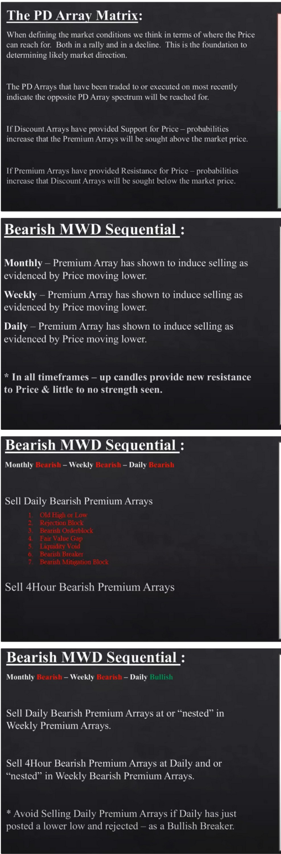

Old High or Low Rejection Block Bearish Orderblock Fair Value Gap Liquidity Void **Bearish Breaker**

Bearish Mitigation Block

**Market Price**

Bullish Millgauon Block "I=

Bullish Breaker g

**Liquidity Void** Fair Value Gap Bull,sh Orderblock Reiechon Block

i5

Old Low or High **PD Array Matrix**

**1 Bearish PD Array Driven**

**I Bearish PD AJTay Driven**

**I Bearish PD AJTay Driven**

**Bearish MWD Se uential** •

**1**

**Bearish PD Array Driven**

\Jonthl1

Sell Daily Bearish Premium Arrays at or --nested.. in Monthly Premium Arrays.

Sell -Hlour Rearish Premium Arrays at Weekly and or

··nested.. in \fonthly Bearish Premium Arrays.

'' .\\l1id Sellin,! \\c•ckh l'rc·111iu11.1·\1Ta\S it"\\cckh ha,_ju,1 puslc·d a k"' c-r k"' and rc·_jcc·tc·d as a llulli,h llrc·akc-r

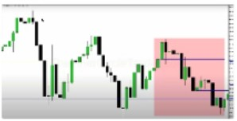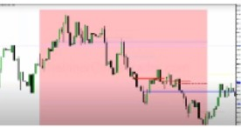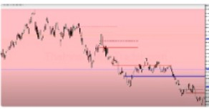

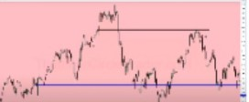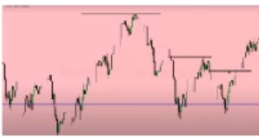

Everytime price moves lower its seeking a discount PD array

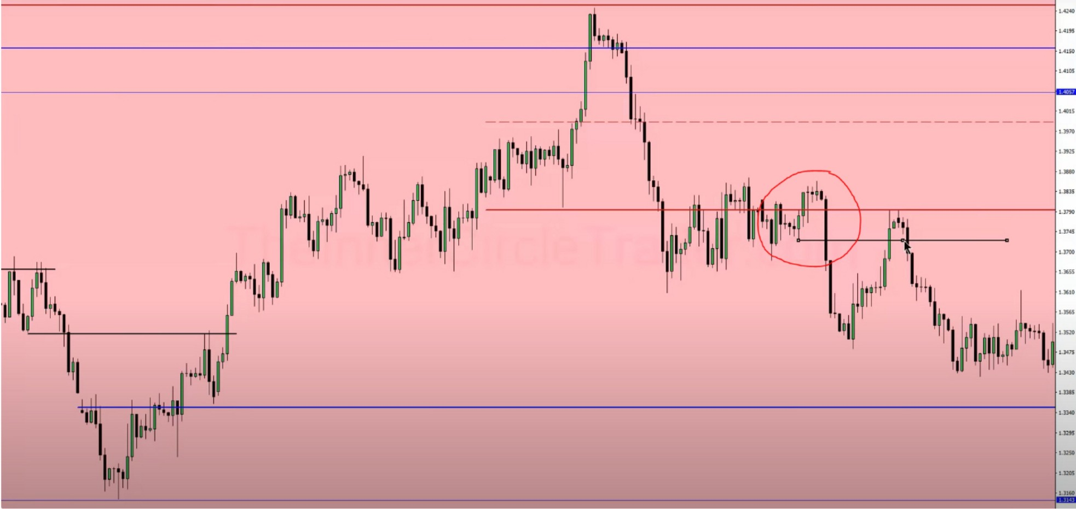

Here the small upcandle at the top, the body is within the bigger upcandle, so then he uses the big candle to the left and not the small one. ICT mostly uses the bigger candles before the downmove

The more overlapping levels we get, the more sensitive the level will likely be. Focus primarily on the monthly and weekly levels, these are the strongest. Monthly and weekly levels can be traded back to multiple times because theyre bigger.

Arjo I Twitter, lnstagram I Linktree

Linktree. Make your link do more.

, https://t.co/HhmmTN1fUI

JavaScript is not available.

*"!I* https://twitter.com/arjoio